LAB 12

1. Write a Python program to sum all the items in a list.

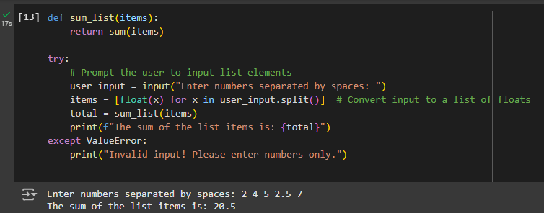

2.Write a Python program to traverse a given list in reverse order, and print the elements with the original index.

Original list: ['red', 'green', 'white', 'black'] Traverse the said list in reverse order: black white green red

